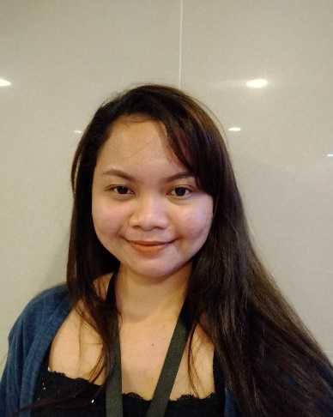

**Alyanna Hope E. Panungcat**

Phone: +639366740785

Email: [alyanna.hope23@gmail.com](mailto:alyanna.hope23@gmail.com)

Address: Block. 13 Lot 3 Phase 2 Tibungco Relocation Davao City, Philippines

|  |
| --- |
| **PROFESSIONAL SUMMARY**  Dedicated and hardworking customer service representative seeking a position as an Appointment Setter. To share the areas that I excel in handling calls; to answer customer’s inquiries, identify customer’s needs in a timely and empathetic manner. To maintain the connection and trust of the customers by meeting their needs and delivers solutions to problems. To handle multiple priorities while meeting tight deadline even under pressure. To show my adaptable and emotionally adjusted attitude. To work and communicate with the team comfortably. |

|  |
| --- |
| **CORE COMPETENCIES**   * Customer service skills * Outbound and inbound calls * Emailing customers * Sales CRM’s like Salesforce, Amazon Worskspace, Teamdot, Bliss Phone * Time management * Organize and detail oriented * Typing works and Microsoft office * Planning and research skills * Teamwork and interpersonal skills * Assistant organizer in an event   **PROFESSIONAL EXPERIENCES**   * **SL (Student Labor)** Nov. 2017- Dec. 2017   *ILCA (Institute of Languages and Creative Arts)*  University of Southeastern Philippines,  Obrero Davao City   * **On-The-Job Training** March - May 2018   *ILCA (Institute of Languages and Creative Arts)*  University of Southeastern Philippines,  Obrero Davao City   * **Customer Service Representative**   *VXI Global Holdings B. V. Phlippines*  Robinson’s Cybergate, Level 2, J.P Laurel Ave, Poblacion District, Davao City, 8000   * **Appointment Setter** Oct 2021- Nov. 2021 |

|  |
| --- |
| **PERSONAL INFORMATION**    Gender: Female  Age: 24 years’ old  Date of birth: July 09, 1997  Citizenship: Filipino    Father’s Name: Allan Jose V. Panungcat (farmer), Mother’s Name: Josephine E. Panungcat  **EDUCATIONAL INFORMATION**  Primary level: F. Bustamante Central Elementary School (2008-2009)    Secondary level: F. Bustamante National High School (2013-2014)    College graduate:  University of Southeastern Philippines  Inigo St., Bo. Obrero, Davao City  Year graduated: June 2018  Bachelor of Arts in Literature |

|  |
| --- |
| **AWARDS ARE RECIPIENTS TO:**   * Consistent Dean’s Lister * Leadership Award * Participation for actively participating in the theatre play in (Union of Literature Students- Unilites organization   **AFFILIATIONS**   * Class Mayor (President)   August 2017 to May 2018   * Rotaract East Davao (member) June 2014- May 2018 * Union of Literature Students (UniLiteS) (member) -- June 2014- May 2018 |

|  |
| --- |
| **REFERENCES**  **Dr. Patricia O. Elbanbuena**  Professor,  University of Southeastern Philippines  Obrero Campus Davao City    **Sheila Lariosa Annabel P. Ornopia**  Part time Professor Public Teacher,  USeP, Obrero Campus Davao City Los Amigos National High School |

**Alyanna Hope E. Panungcat**

Blk. 13 Lot 3 Phase 2 Relocation

Tibungco Davao City, 8000

**name**

position

office

usep

Sir,

Greetings!

I am a 20-year-old applying for an Office Staff position in your company. I am a graduate of Bachelor of Arts in Literature in University of Southeastern Philippines. I also work as a Student Labor or an assistant in the university. I am an OJT trainee at Institute of Languages and Creative Arts of the College of Arts in Sciences in University of Southeastern Philippines. I also have a good scholastic report such as a consistent Dean’s Lister as well as intellectual achievements like Leadership award that would fit as a deserving candidate for this position.

I am willing to apply and share what I have learned from my education and nurture the talent that I have. I have been proficient in Microsoft and good in oral and written communications. I have been assigned as information desk and served as an assistant organizer. I am also capable in handling liquidation, answering calls, checking papers and even in managing inventory. I can easily work effectively and communicate with others. I am adaptable and emotionally adjusted. I can handle problems even under pressure and meet the deadlines of a certain task. I am willing to be part and be a great contributor to your office.

I would appreciate the opportunity to review my resume attached for further information of my professional experiences, education, achievements, skills to perform as an Office Staff in your team. Feel free to call me, 09366740785 or email me at [alyanna.hope23@gmail.com](mailto:alyanna.hope23@gmail.com) for clarifications. I am confident that you will find me more energetic and devoted for this job. I will confidently work hard and be an asset to your firm. Thank you and more power.

Respectfully,

**Alyanna Hope E. Panungcat**

Applicant